# Questions

## Question 1

FL Review - start at 13:51

Q1

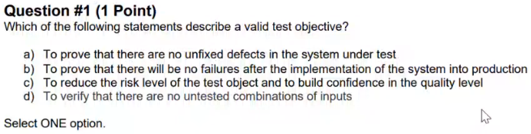

Q1 - Answer

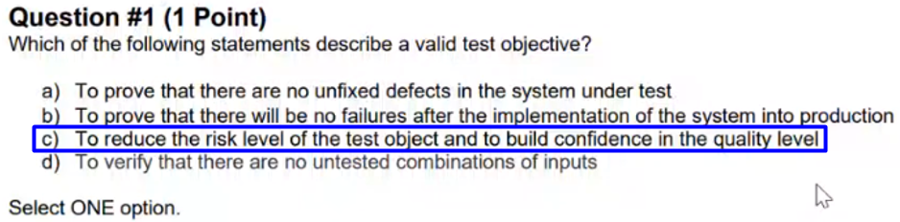

## Question 2

FL Review - start at 18:56

Q2

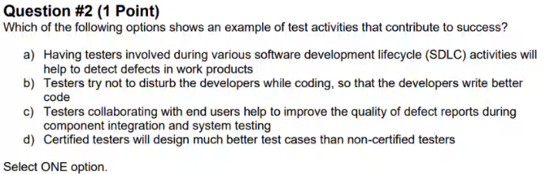

Q2 - Answer

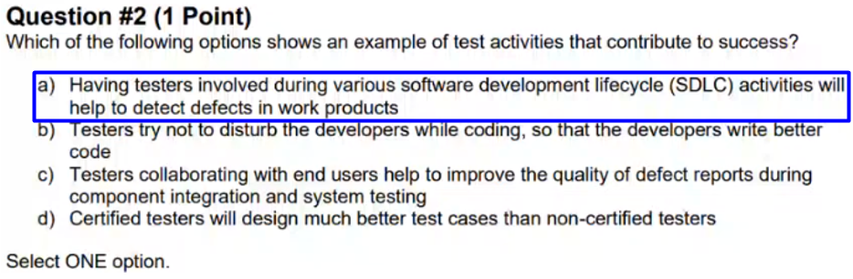

## Question 3

FL Review - start at 21:42

Q3

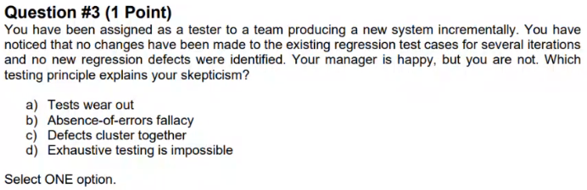

Q3 - Answer

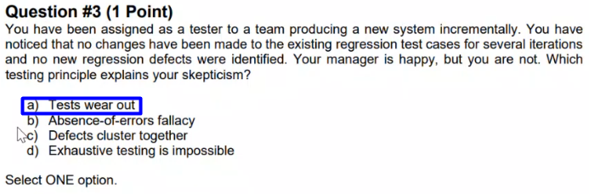

## Question 4

FL Review - start at 24:30

Q4

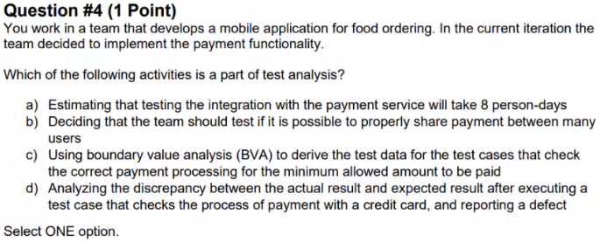

Q4 - Answer

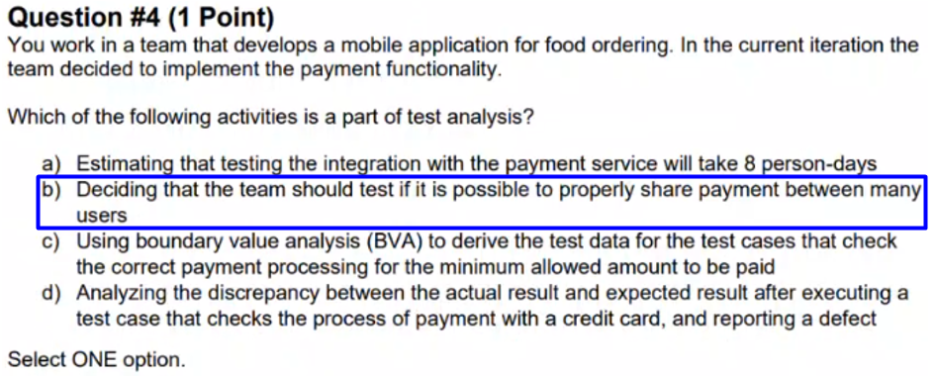

## Question 5

FL Review - start at 28:34

Q5

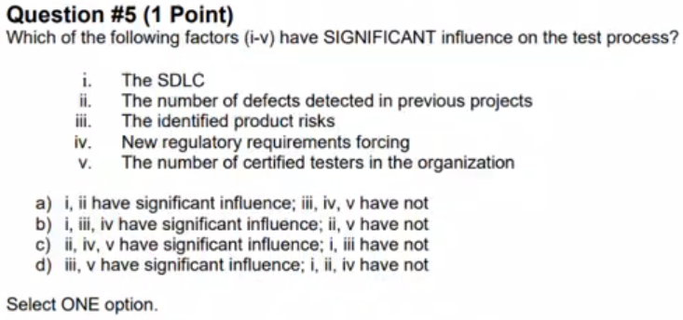

Q5 - Answer

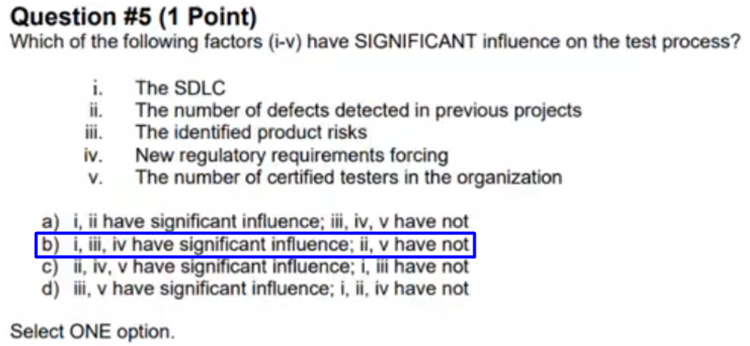

## Question 6

FL Review - start at 32:42

Q6

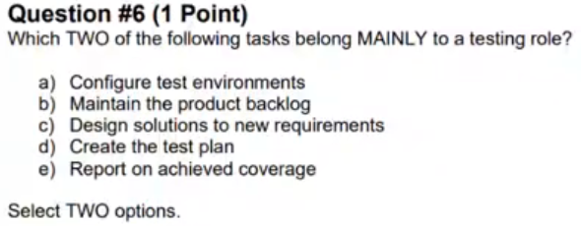

Q6 - Answer

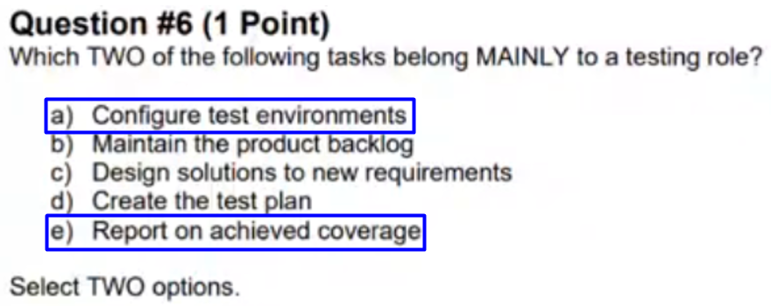

## Question 7

FL Review - start at 35:43

Q7

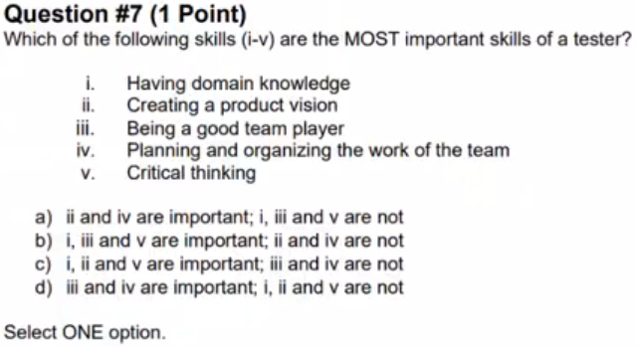

Q7 - Answer

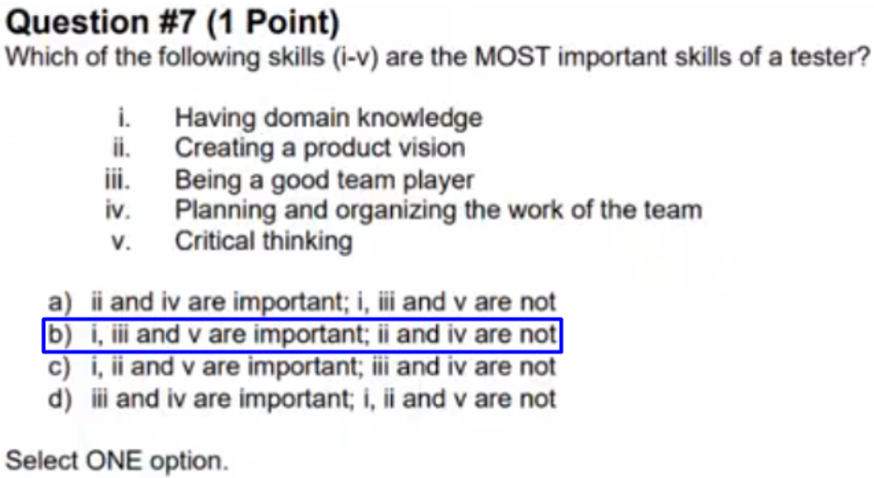

## Question 8

FL Review - start at 37:34

Q8

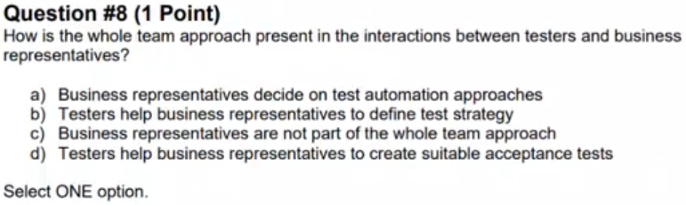

Q8 - Answer

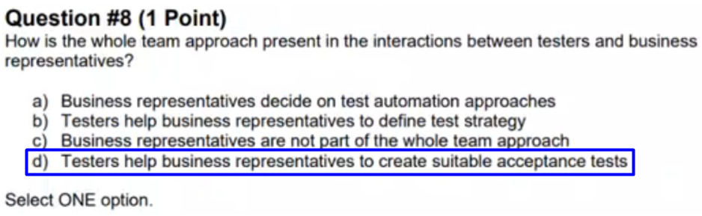

## Question 9

FL Review - start at 39:36

Q9

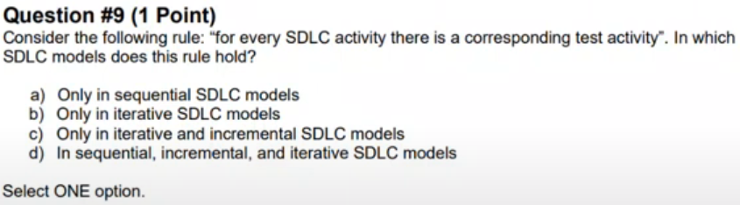

Q9 - Answer

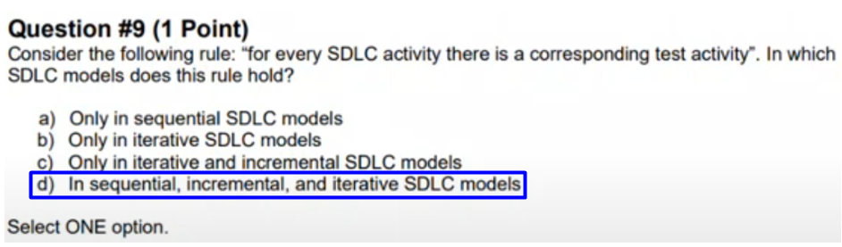

## Question 10

FL Review - start at 40:43

Q10

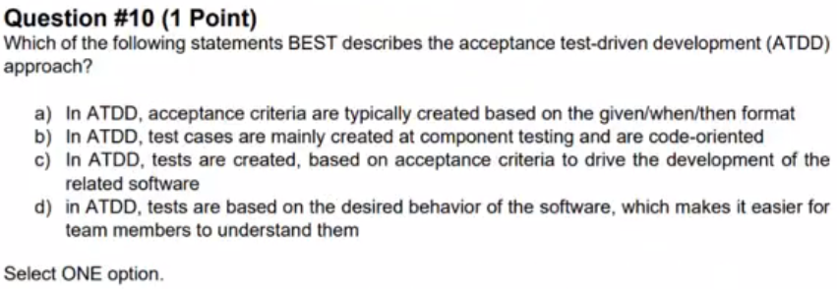

Q10 - Answer

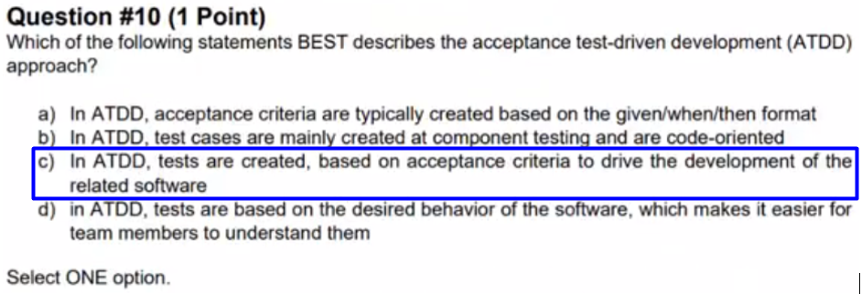

## Question 11

FL Review - start at 42:17

Q11

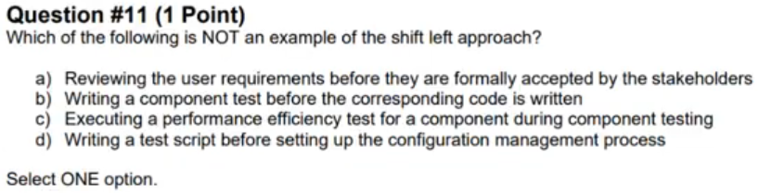

Q11 - Answer

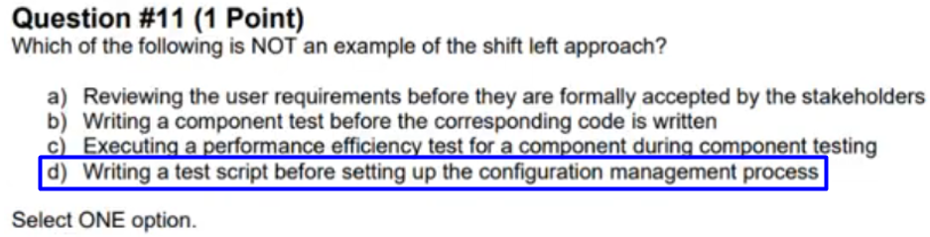

## Question 12

FL Review - start at 46:23

Q12

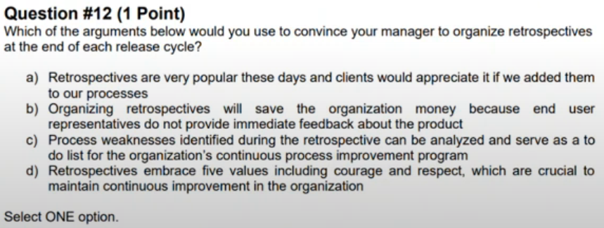

Q12 – Answer

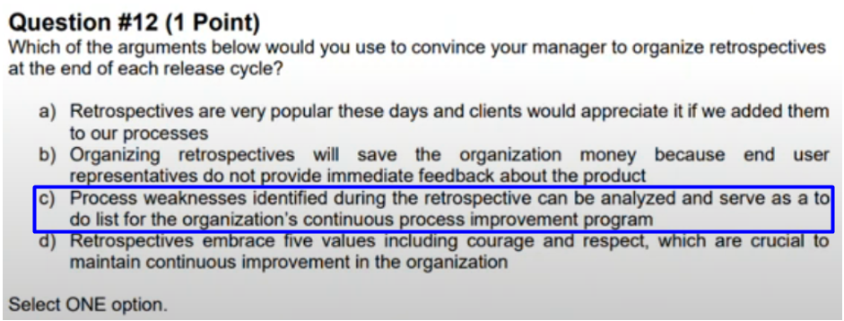

## Question 13

FL Review - start at 48:45

Q13

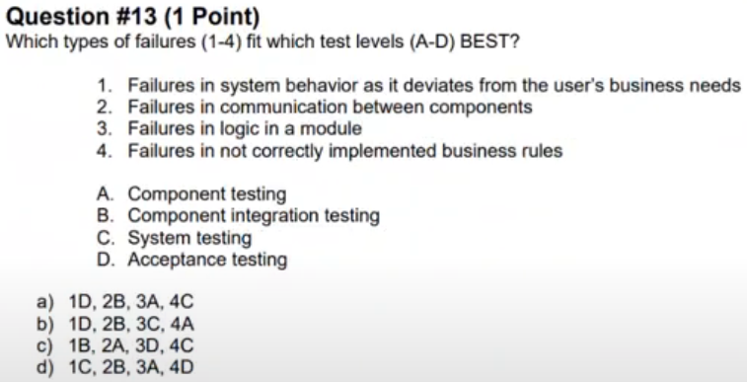

Q13 - Answer

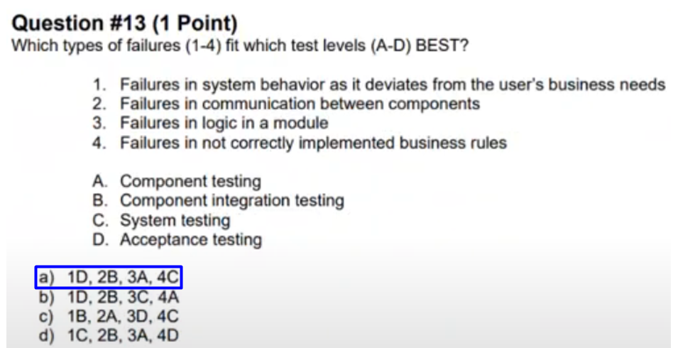

## Question 14

FL Review - start at 50:44

Q14

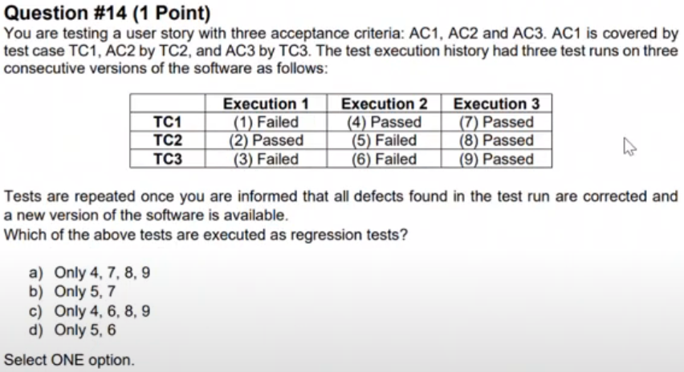

Q14 - Answer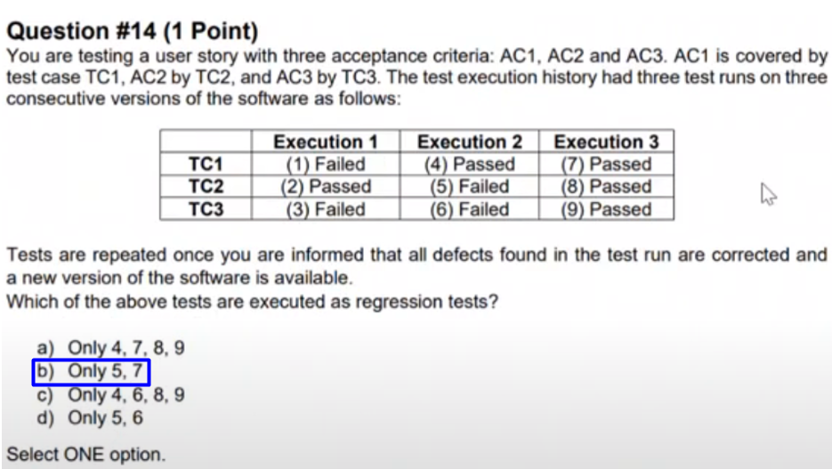

## Question 15

FL Review - start at 55:22

Q15

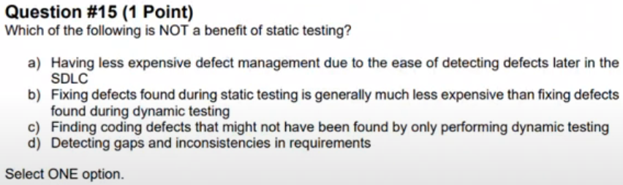

Q15 - Answer

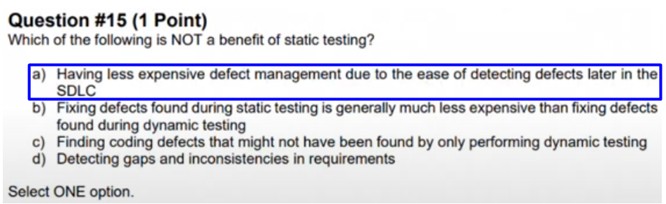

## Question 16

FL Review - start at 59:07

Q16

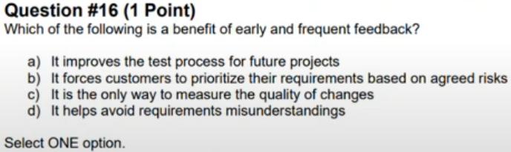

Q16 - Answer

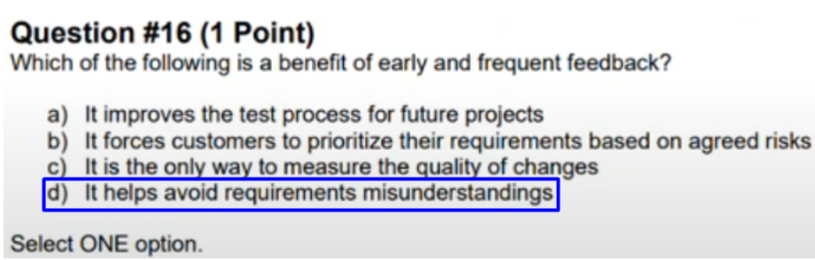

## Question 17

FL Review - start at 1:00:37

Q17

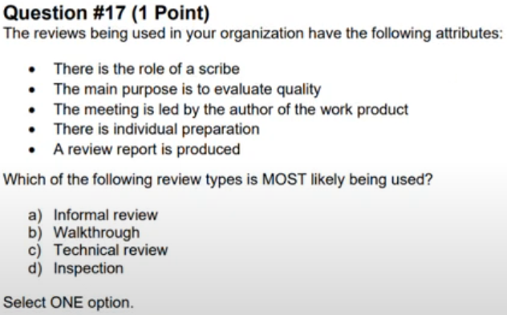

Q17 - Answer

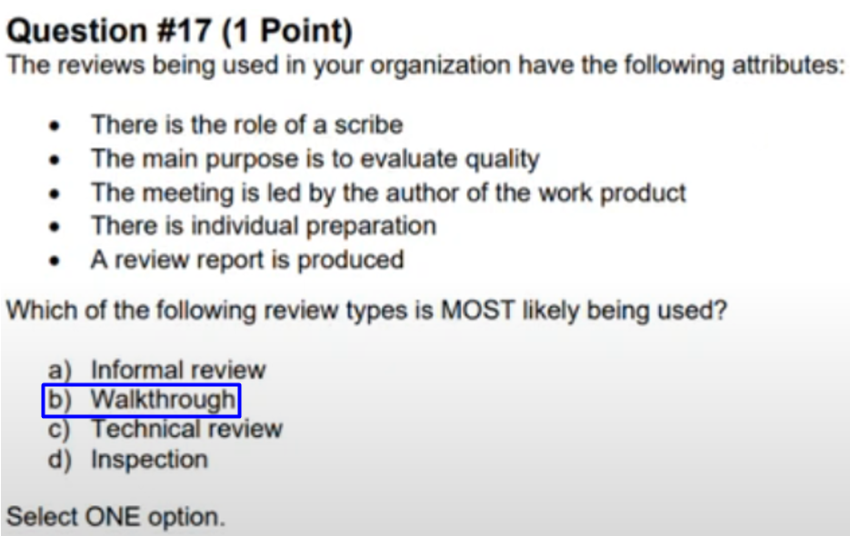

## Question 18

FL Review - start at 1:02:07

Q18

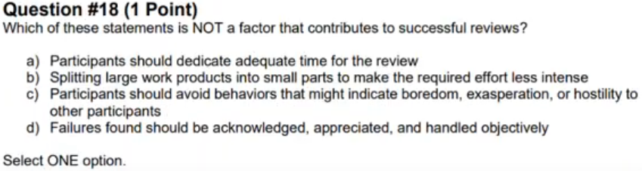

Q18 - Answer

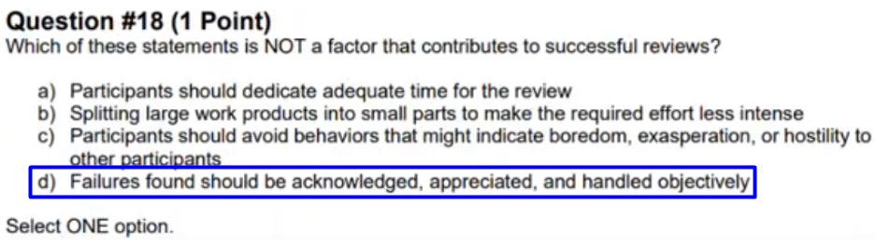

## Question 19

FL Review - start at 1:03:55

Q19

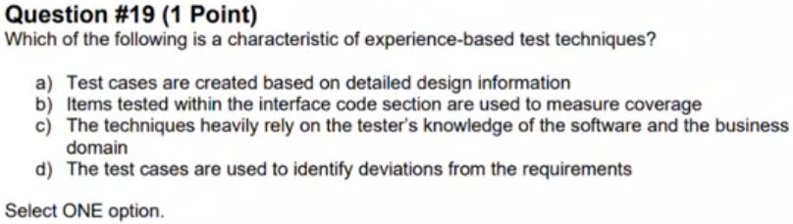

Q19 - Answer

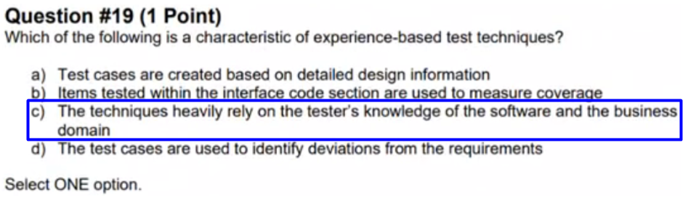

## Question 20

FL Review - start at 1:05:20

Q20

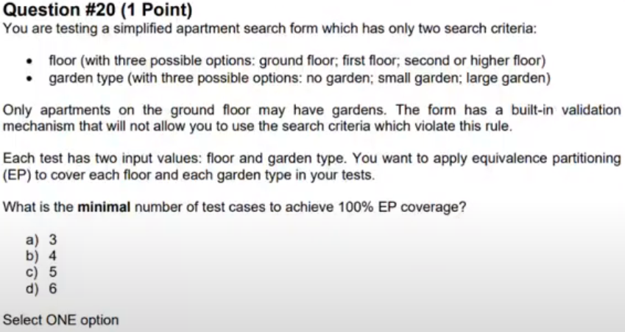

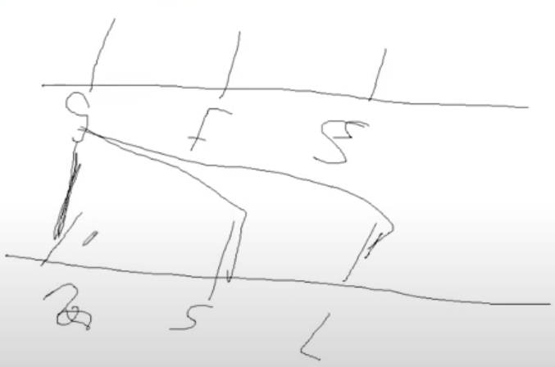

Q20 - Answer

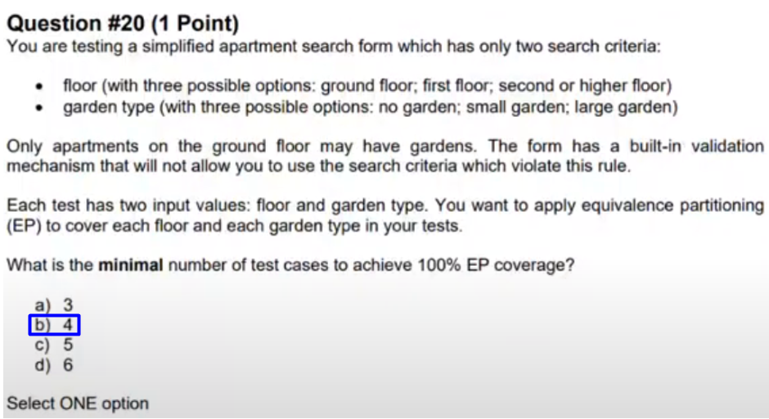

## Question 21

FL Review - start at 1:12:52

Q21

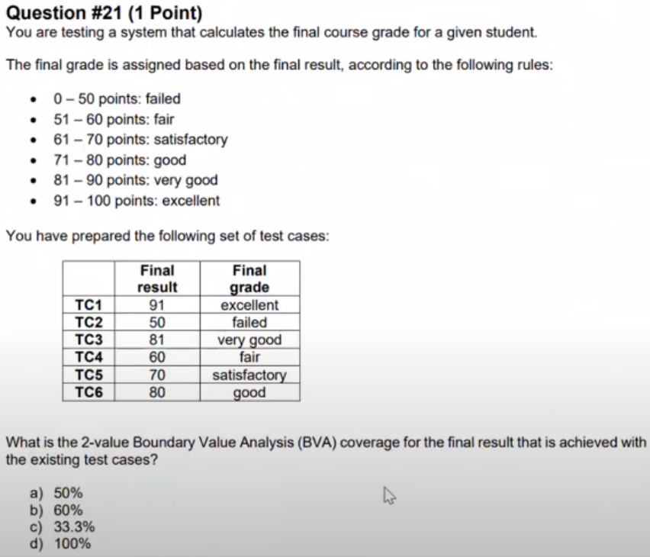

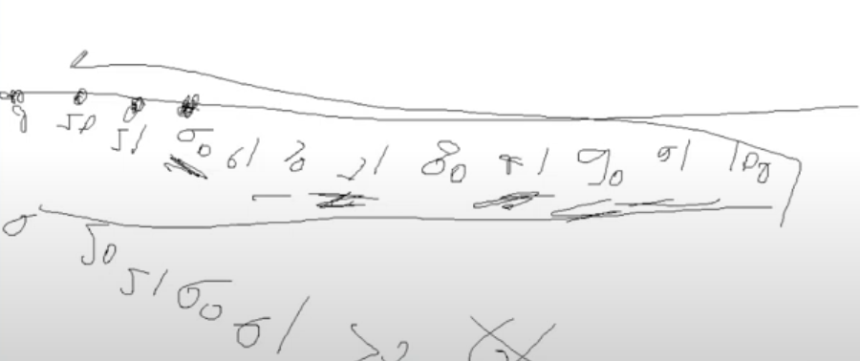

Q21 - Answer

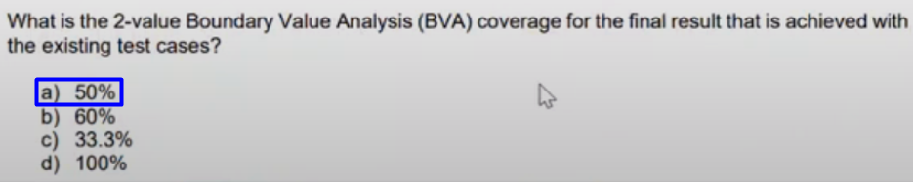

## Question 22

FL Review - start at 1:21:54

Q22

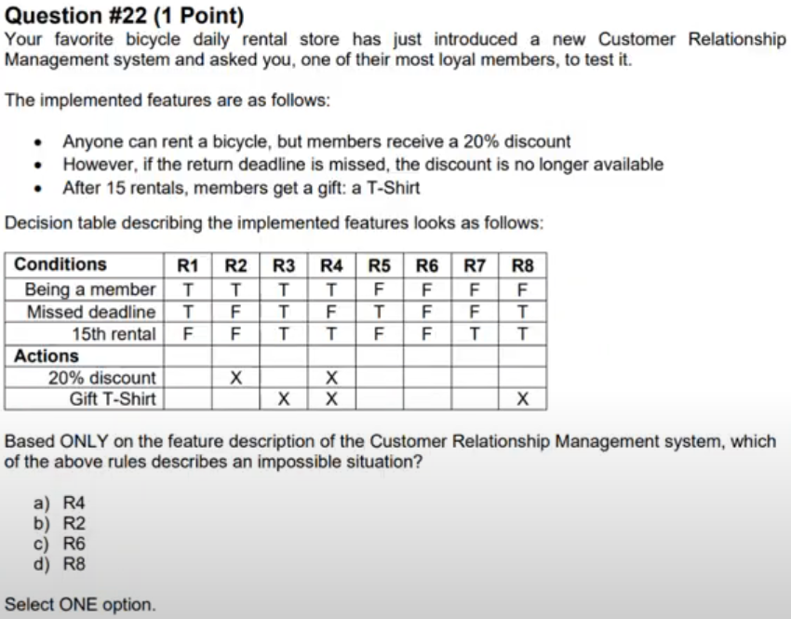

Q22 - Answer

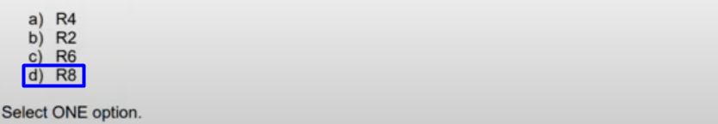

## Question 23

FL Review - start at 1:25:24

Q23

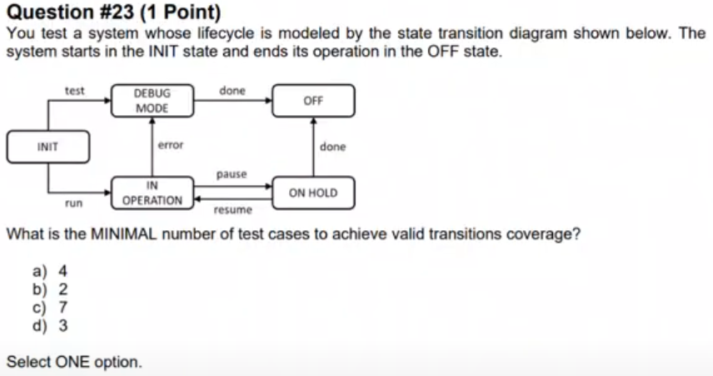

Q23 - Answer

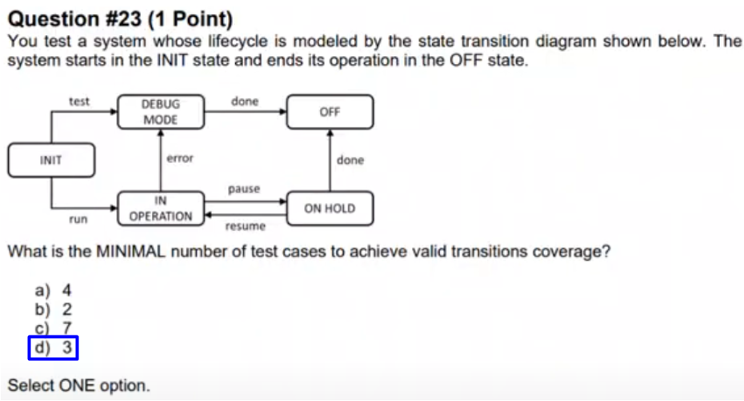

## Question 24

FL Review - start at 1:29:39

Q24

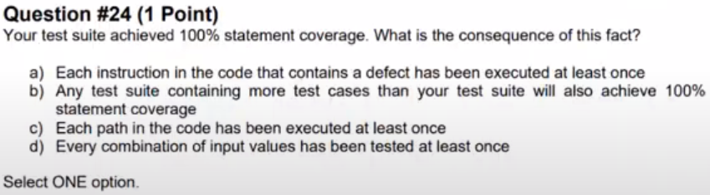

Q24 - Answer

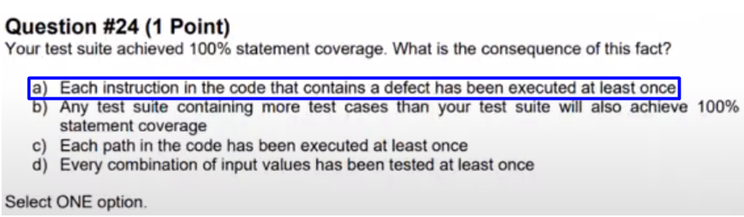

## Question 25

FL Review - start at 1:32:18

Q25

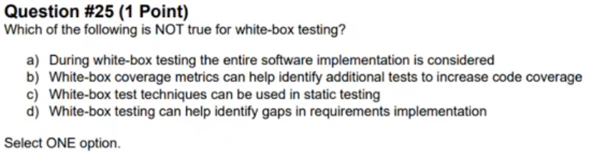

Q25 - Answer

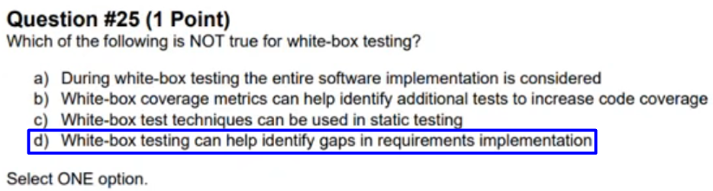

## Question 26

FL Review - start at 1:36:54

Q26

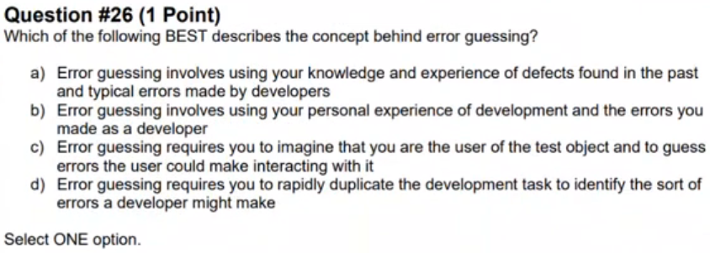

Q26 - Answer

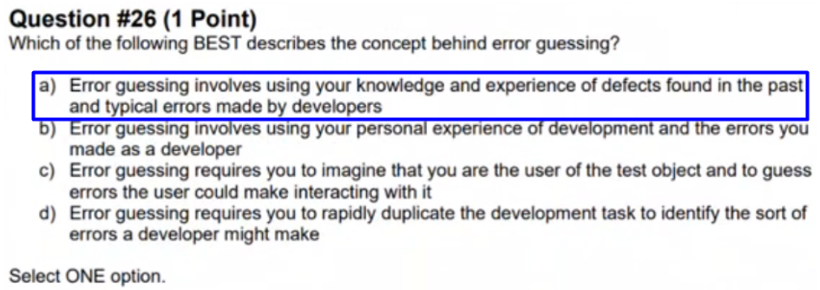

## Question 27

FL Review - start at 1:39:49

Q27

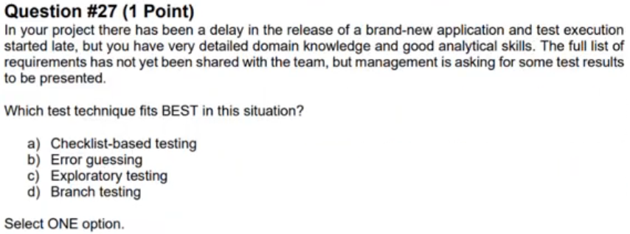

Q27 - Answer

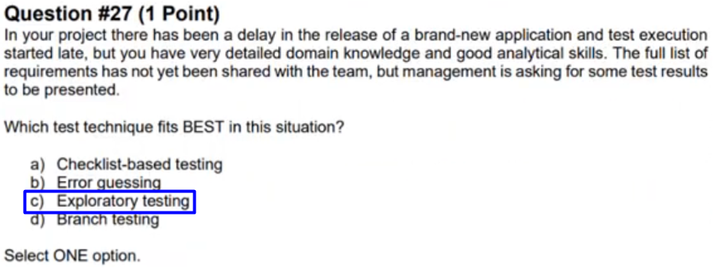

## Question 28

FL Review - start at 1:42:17

Q28

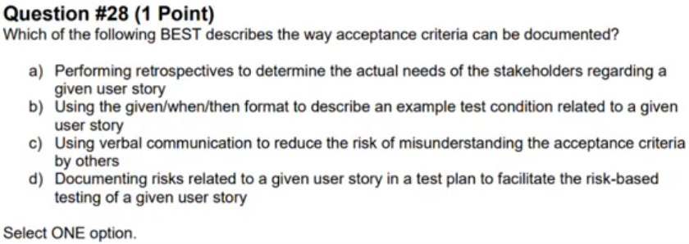

Q28 - Answer

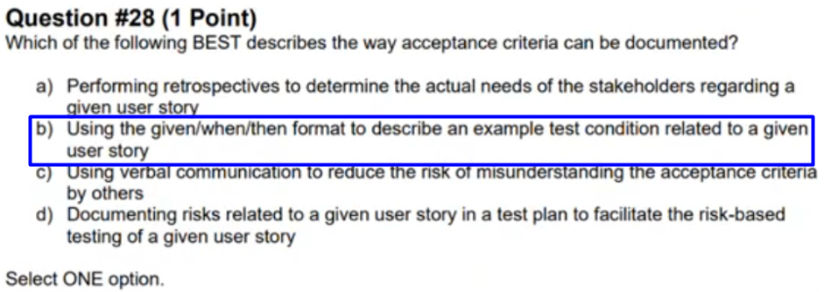

## Question 29

FL Review - start at 1:46:40

Q29

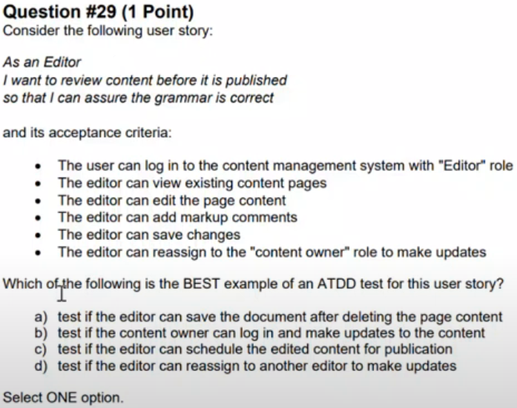

Q29 - Answer

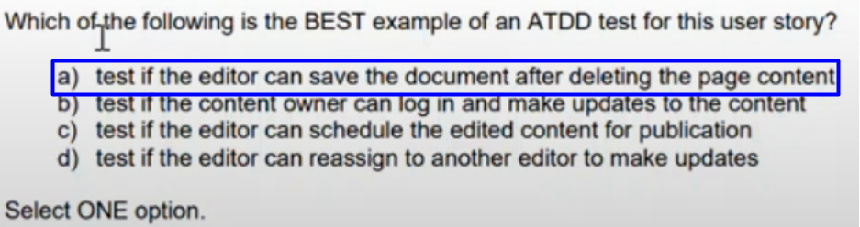

## Question 30

FL Review - start at 1:50:37

Q30

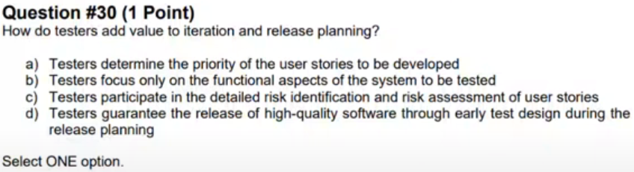

Q30 - Answer

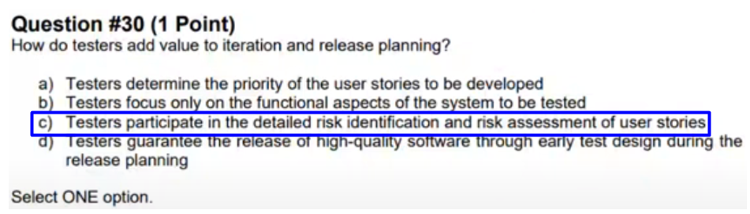

## Question 31

FL Review - start at 1:53:44

Q31

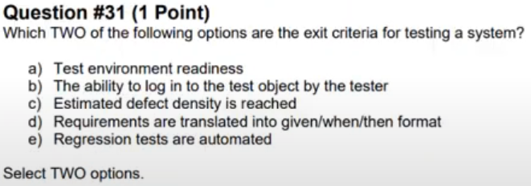

Q31 - Answer

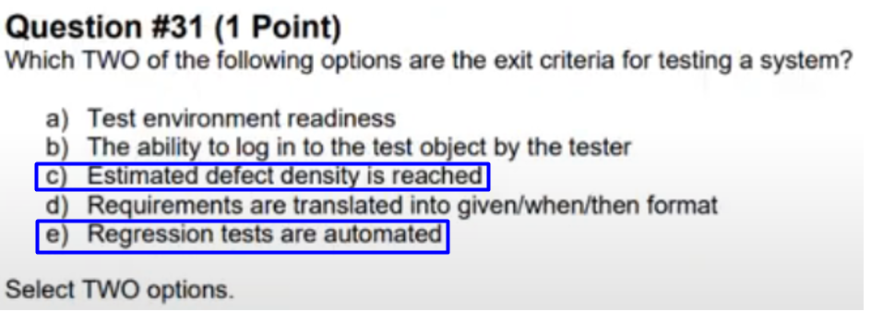

## Question 32

FL Review - start at 1:58:18

Q32

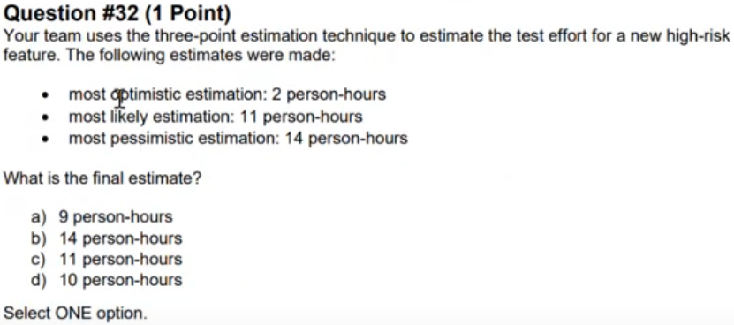

Q32 - Answer

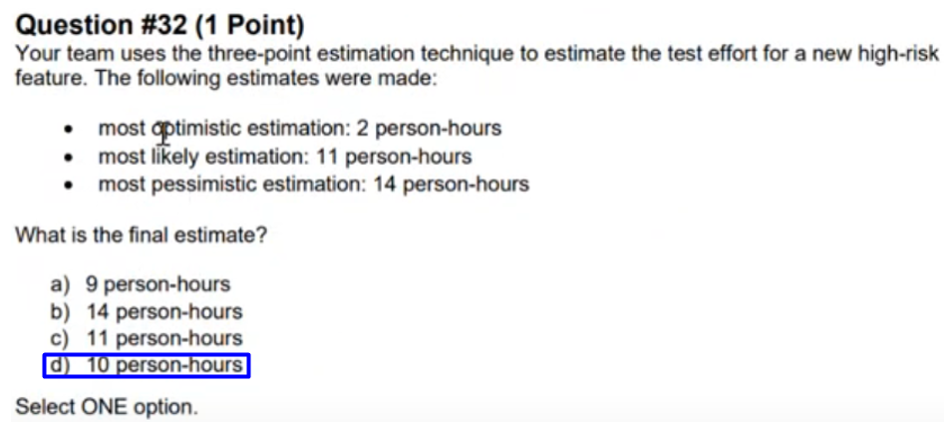

## Question 33

FL Review - start at 2:00:05

Q33

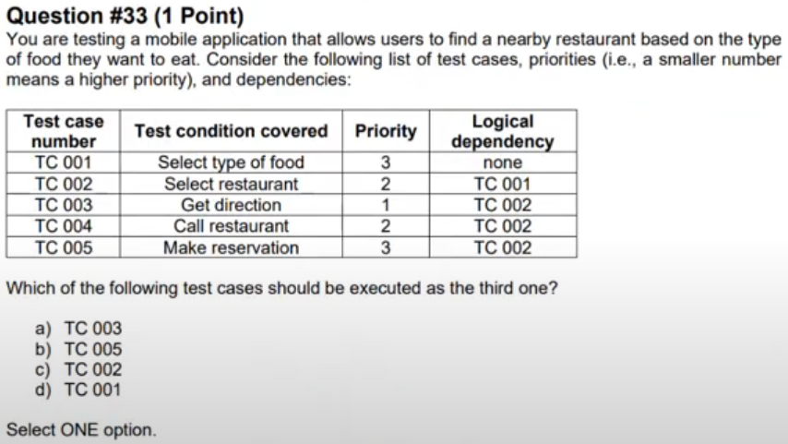

Q33 - Answer

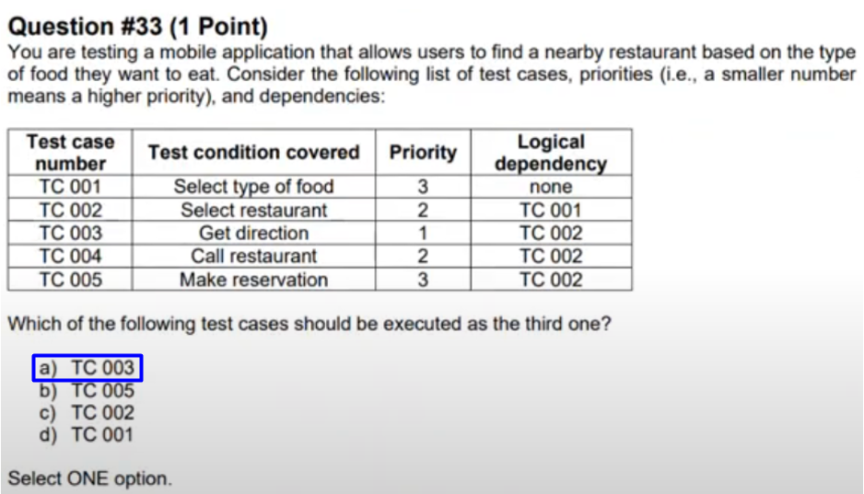

## Question 34

FL Review - start at 2:02:50

Q34

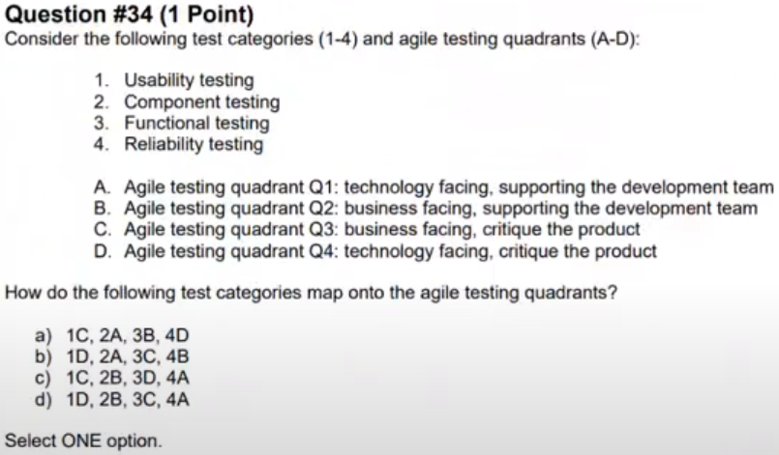

Q34 - Answer

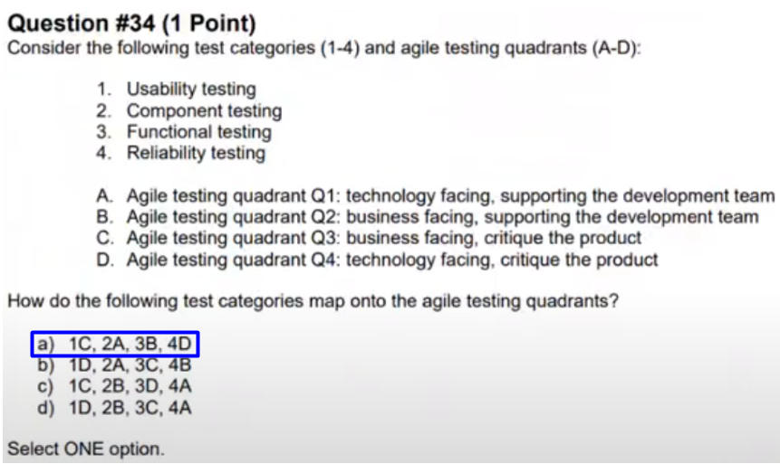

## Question 35

FL Review - start at 2:09:03

Q35

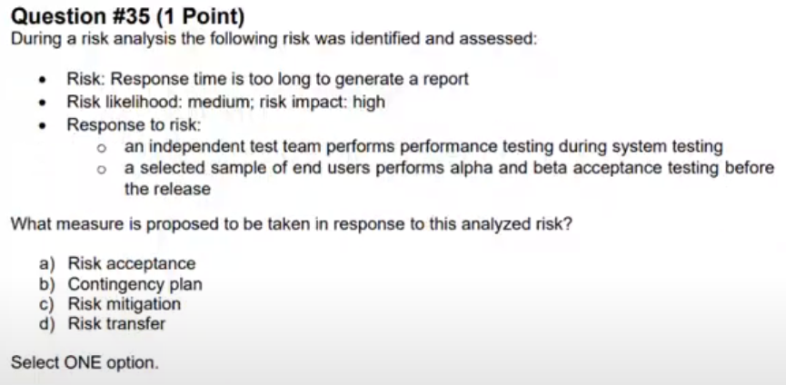

Q35 - Answer

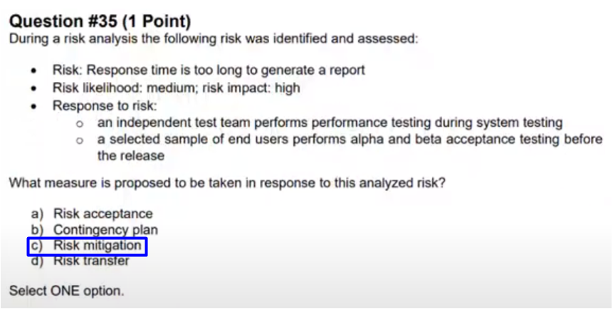

## Question 36

FL Review - start at 2:11:00

Q36

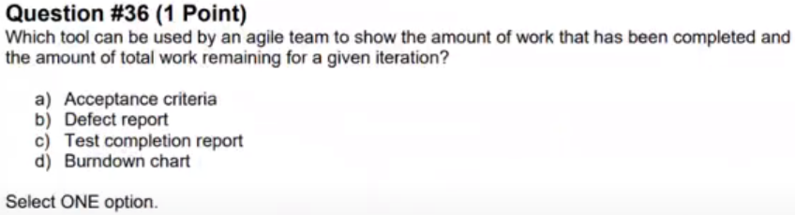

Q36 - Answer

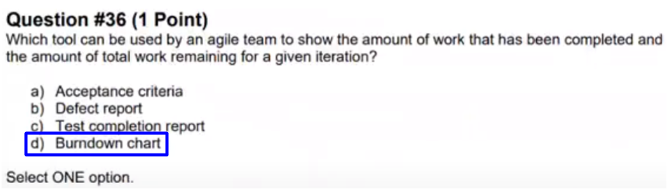

## Question 37

FL Review - start at 2:12:08

Q37

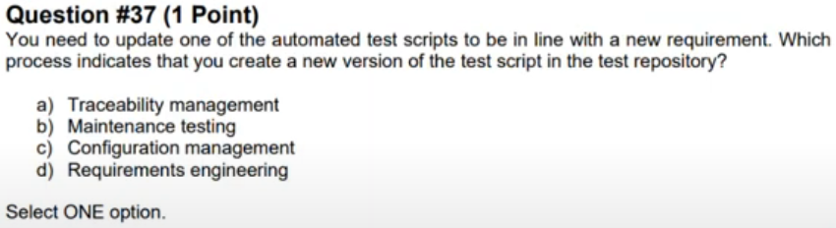

Q37 - Answer

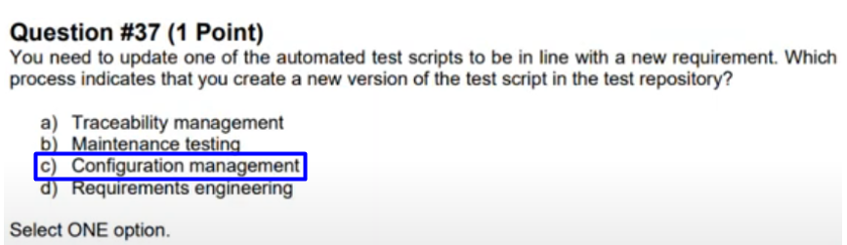

## Question 38

FL Review - start at 2:14:13

Q38

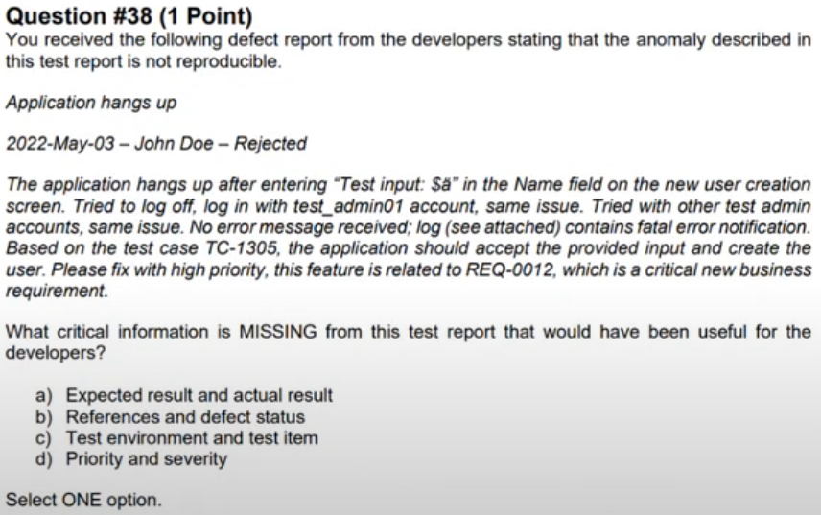

Q38 - Answer

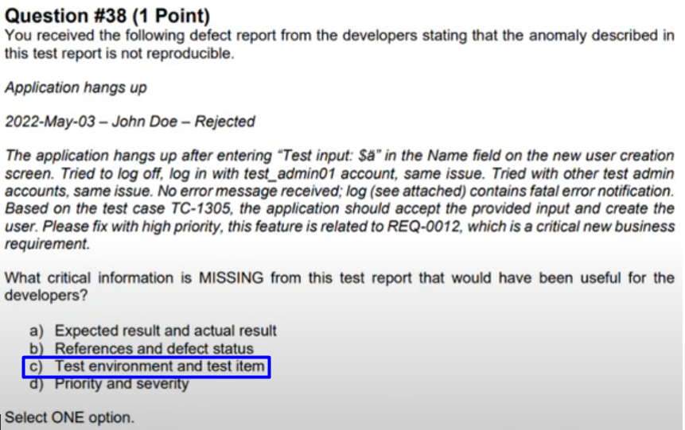

## Question 39

FL Review - start at 2:17:26

Q39

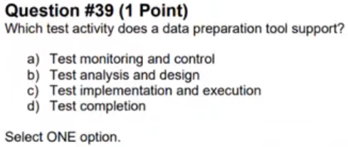

Q39 - Answer

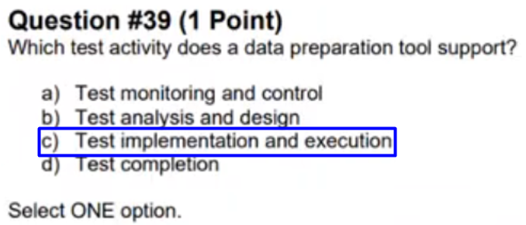

## Question 40

FL Review - start at 2:18:21

Q40

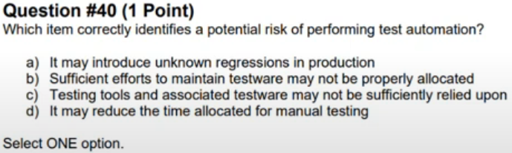

Q40 - Answer

